Global AI Tool Adoption Analysis
Overview
This project aims to analyze and visualize global adoption trends of AI tools across countries, industries, company sizes, and demographics. The goal is to identify where adoption is strongest, how fast it’s growing, and which segments are driving engagement.

Datasheet Description

1. Country
- Represents the geographic location of adoption.
- Useful for country-wise adoption comparisons.

2. Industry
- Identifies the sector (e.g., healthcare, finance, education).

3. AI Tool
- Specifies the AI technology/tool being adopted.
- Helps track tool-specific adoption trends .

4. Adoption Rate
- Percentage of organizations/users adopting the tool.
- Core metric for overall adoption rate, growth rate (YoY).

5. Year
- Time dimension for tracking adoption trends.

6. Age Group
- Demographic segmentation of users.

7. Daily Active User (DAU)
- Engagement metric showing active usage.

8. Company Size
- Categorizes organizations (Small, Medium, Large).

Scope of Analysis

1. Global Adoption Trends
- Overall Adoption Rate (%) → Average adoption across all countries and industries.
- Global Daily Active Users (DAU) → Engagement measure across tools and regions.

2. Industry Adoption Rate (%) → Average adoption per industry.
- Top Industries by Adoption → Rank industries by adoption rate.

3. Company Size Segmentation
- Company Size Adoption Split → Compare adoption across Small, Medium, Large companies.

4. Demographic Insights
- Age Group Adoption → Adoption patterns across age group.
- Engagement by Age Group → DAU segmented by demographics.
Exploratory Data Analysis using Python
We began with data preparation and cleaning in Python:
● Data Loading: Imported the dataset using pandas.

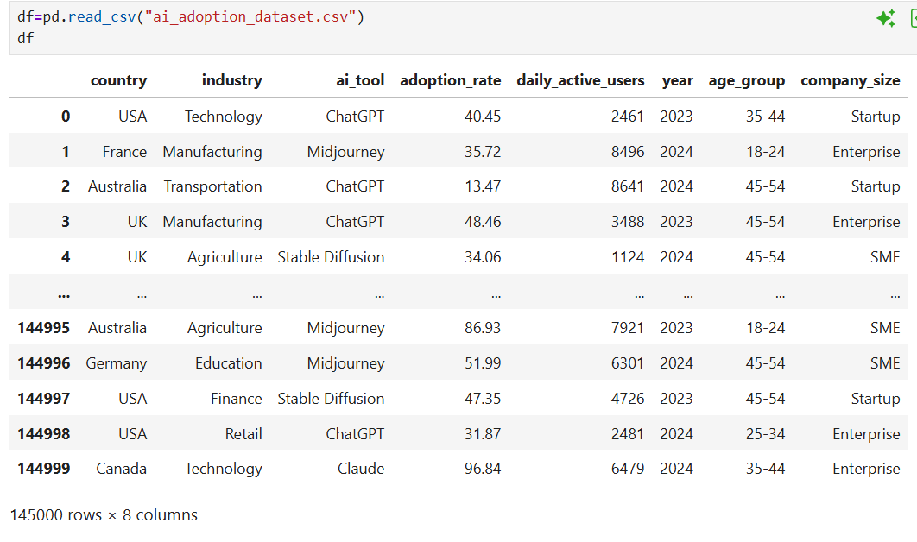
● Initial Exploration: Used df.info() to check structure and .describe() for summary statistics.
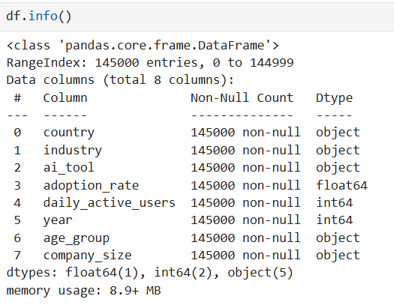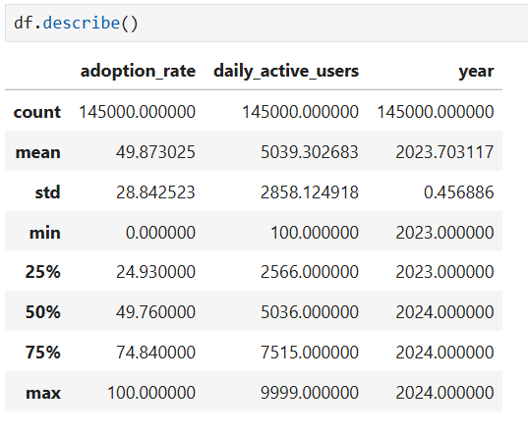

- Data Handling: Checked for null values and duplicates values.
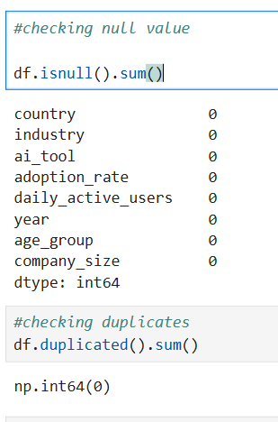

Data Analysis using SQL
We began with data preparation, cleaning and structured analysis in SQL SERVER :

Data Loading: First we create a Database in SQL Server and then load data which is in csv file format with the help of task option.

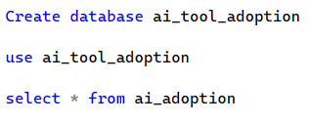

Initial Exploration: Find out the total number of records we have for analysis.
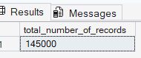

Overall Adoption Rate (%): Find out the overall adoption rate of ai tools.

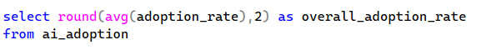

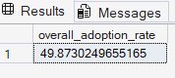

Global Daily Active Users: Find out the daily active users across the world those are using the ai tool.

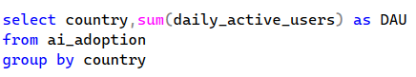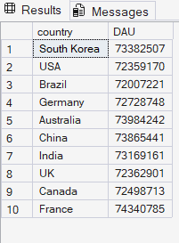

Industry adoption rate: Find out the adoption rate in different industries.

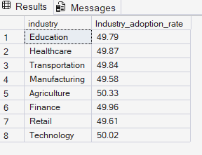

Top Industries by Adoption rate: Find out the top 5 industry.
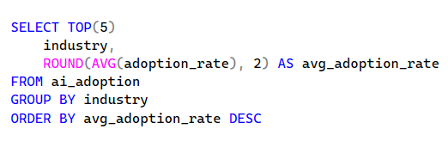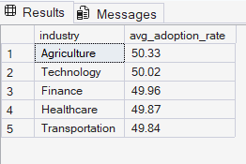

Company Size by Adoption Rate: It shows how AI tool adoption varies across the different size of organisation.
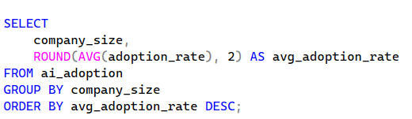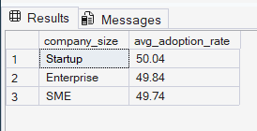

Age Group Adoption Rate: It shows how AI tool adoption varies across the different age group.

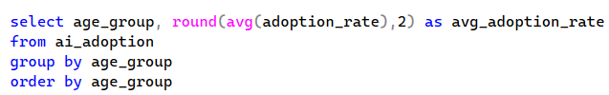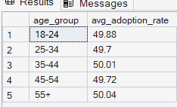

Total Daily Active User by AI Tool: Find out the total active user by each ai tool on every day.
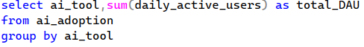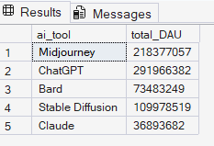

Average Daily Active User by AI Tool: Find out the average daily active user by ai tool.

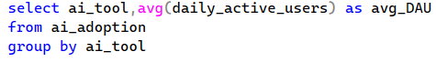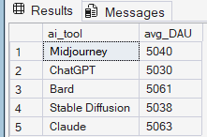

DASHBOARD IN POWER BI
Finally, we built an interactive dashboard in Power BI to present insights visually.
